**-TABLES-**

**Relational Table Definition**

This definition is the base for creating the tables in the database. In general it gives the same information as the ERD but in a more specific way.

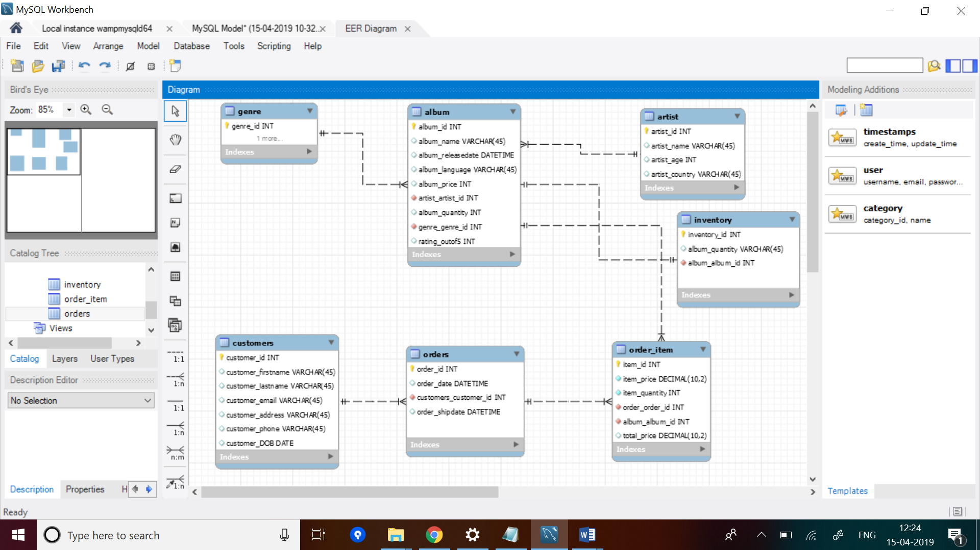

Here is a brief screen shot from EER Model Diagram of our music store.



There are seven tables in the database “musicstoredatabase”. They are listed below.

o Album

o Customer

o Artist

o Genre

o Orders

o Order_item

o Inventory

Description of the two tables customers and orders are as below:

**Customers:**

o customer_id : This is a primary key of the customers table, which uniquely identifies the customer. It has an integer data type.

o customer_firstname: This attribute gives information about the first name of the customer. It has a data type of VARCHAR(45)

o customer_lastname : This attribute gives information about the last name of the customer. It has a data type of VARCHAR (45)

o customer_email: This attribute gives information about the email address of the customer. It has a data type of VARCHAR (45)

o customer_address: This attribute stores information about the home addresses of the customer. It has a data type of VARCHAR (45)

o customer_phone: This attribute stores phone number of the customer. It has an integer data type.

o customer_DOB: This attribute stores date of birth of the customer. It has a data type of DATE

Customers tables is in one to many relationship with the Orders table, as each customer of the store can have more than order.

**Orders:**

o order_id: This is a primary key of the orders table, which would uniquely identify the order of a customer. It has a data type of INT

o order_date: This attribute gives information of the date along with time on which the order was placed. It has a data type of DATETIME.

o order_shipdate: This attribute gives information of the date along with time on which the order was sent to the customer. It has a data type of DATETIME.

o customers_customer_id: This is a foreign in this table which comes from the customer table. It has a data type of INT.

Orders table is in many to one relationship with the customers table.

And also Orders table is in one to many relationship with the Order_item table